Crimson Year, Github Merge Conflicts

When pulling the “latest changes from main” you may end up editing the same line of code that another team member has edited and merged recently. It will look something like this.

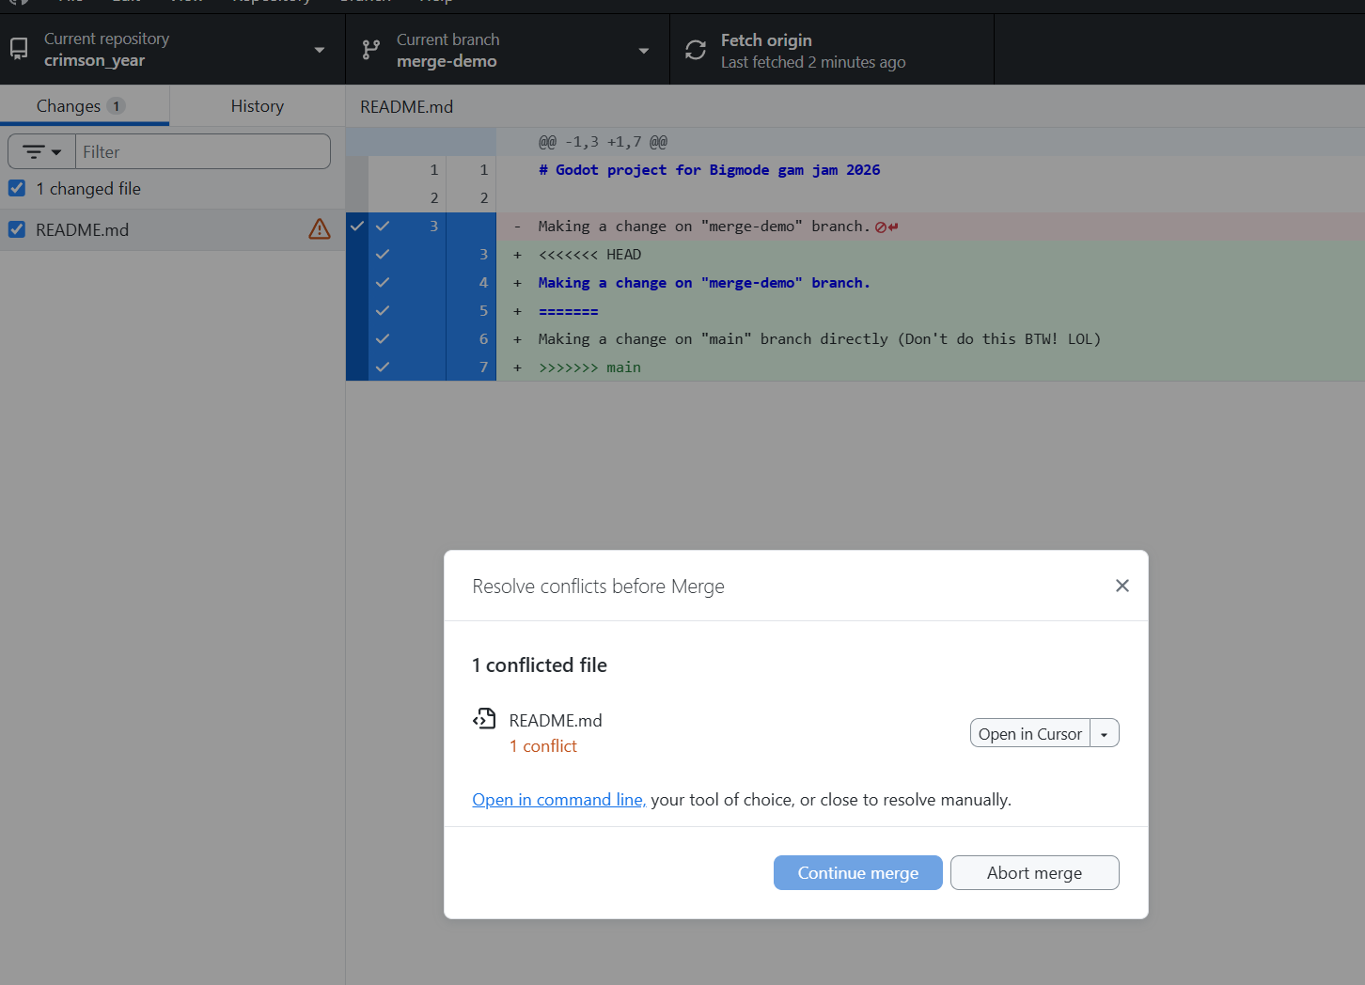

In this situation you’ll need to open the file in a text/code editor and resolve the conflict. In my editor I’m given convenient buttons to “accept incoming changes”, which is most of the time what you’d want to do in these situations. It really depends on the file and situation though
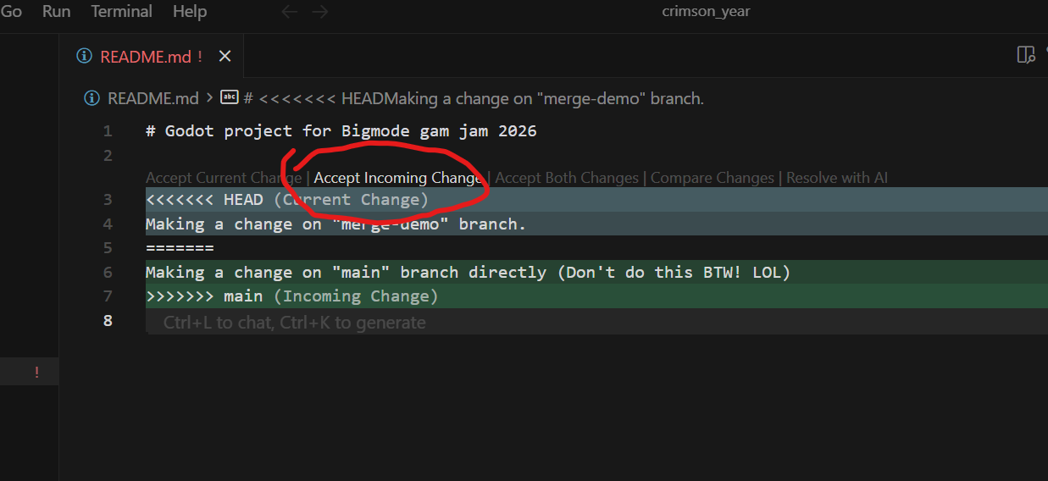

If this is a scene file (.tscn), I’m not sure exactly how this is going to go yet, please alert me (Klynicol) if this happens so we can take a closer look together.
After the merge conflicts have been solved and saved you can head back to your Github Desktop and commit that merge. Usually I title that commit like “Merged main”
